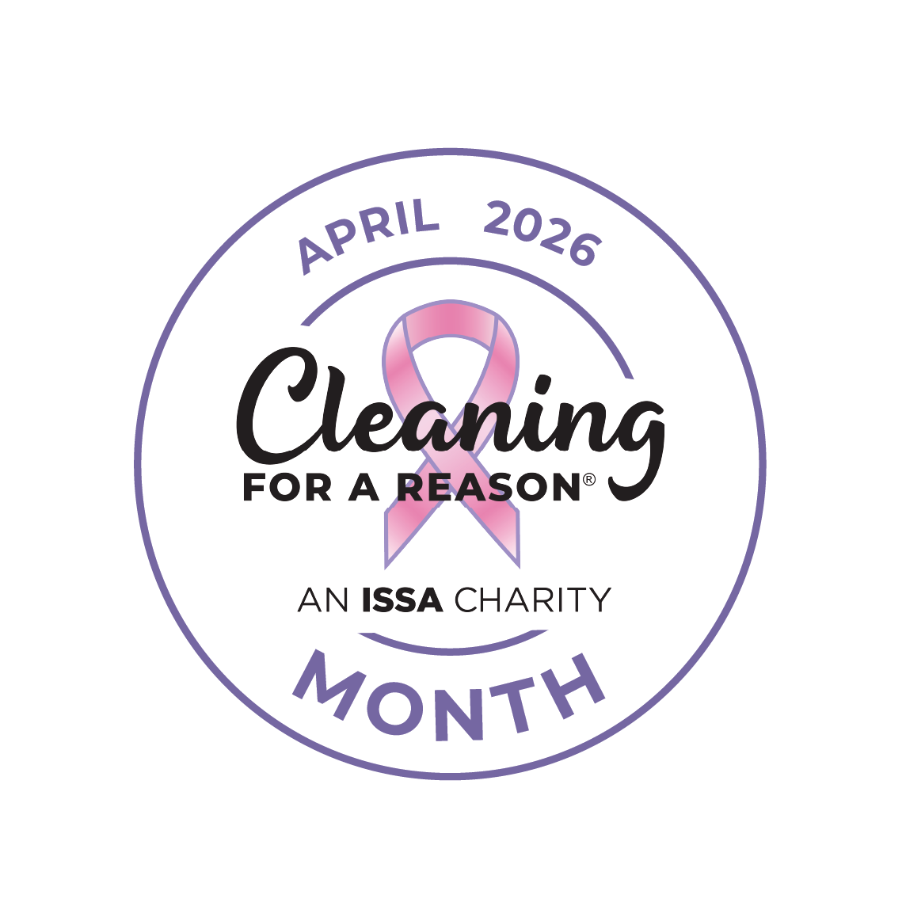
National Cleaning for a Reason Month, April 1-30, 2026

How To Request a Proclamation from the Governor or Mayor
Start the process now, as the wheels of government often turn slowly. Proclamation procedures can vary by city or state, but in most cases, the steps are:
- Locate the appropriate city or state government website.
  - Find a tab called “Governor's Page” or “Mayor’s Page.” Also look for “Ceremonial” or “Forms” down the side or across the top. If you do not see any of these, use the site's Search feature with the word “proclamation.”
  - If a form is required, copy the information from the attached cover letter and proclamation template below into the form and submit it.
  - Another option is to email or mail the attached cover letter and proclamation template to the governor or mayor’s office. Most will use this proclamation as it stands.
- Follow up with an email or phone call—just to be sure your request for a proclamation has arrived.
- When you have confirmation the proclamation has been signed, contact local media to suggest a news item, interview, or photo with the mayor or governor.
- Once received, email a copy of the signed proclamation and any media coverage or photos to lucy@cleaningforareason.org.
<Date>
<Governor or Mayor First Name Last Name>
<City, State>
Dear <Governor or Mayor First Name Last Name>.
On behalf of <Your Company Name> and in partnership with Cleaning for a Reason, an ISSA Signature Charity, I respectfully request a proclamation declaring April 1–30, 2026 as National Cleaning for a Reason Month. This month highlights the nonprofit’s vital mission to provide free home cleanings to cancer patients, ensuring more families receive essential support while inspiring community members and local businesses to give back through donations, volunteer efforts, or partnerships. A sample proclamation is attached for your convenience.
This year, Cleaning for a Reason is celebrating 20 years of compassion, care, and cleaning homes. They’ve partnered with more than 1,400 cleaning companies across the U.S. and Canada, provided over 65,000 cancer patients with donated cleanings valued at more than $23 million.
Fighting cancer is an overwhelming challenge, and immunocompromised patients should not have to worry about maintaining a clean, safe, and healthy home. Cleaning for a Reason lifts that burden, giving patients peace of mind and the freedom to focus on healing and spending precious time with loved ones. To learn more, please visit www.cleaningforareason.org.
Thank you for your consideration. Please contact me with any questions.
Sincerely,
[Your Name]
[Your Title / Company]
[Contact Information]

National Cleaning for a Reason Month, April 1–30, 2026
PROCLAMATION
<City or State>
EXECUTIVE OFFICE of <GOVERNOR OR MAYOR >

WHEREAS, Cleaning for a Reason is a 501(c)3 nonprofit that provides free professional house cleaning to cancer patients, matching families with volunteer cleaning companies who donate their time and services; and
WHEREAS, a clean, safe, and healthy home can make a meaningful difference for cancer patients and their families, allowing them to focus on healing and quality family time during an already challenging time; and
WHEREAS, Cleaning for a Reason partners with more than 1,400 professional cleaning companies across the U.S. and Canada, having provided over 65,000 cancer patients with donated cleanings valued at more than $23 million, and continues to grow each year to help even more patients; and
WHEREAS, community support—including donations of any size—helps this vital mission reach more cancer patients and bring care and comfort to families across our city and state.
NOW, THEREFORE I, _________________(Name), __________________(Title)
_________________________________________________________, (City/State)
DO HEREBY PROCLAIM April 1–30, 2026 National Cleaning for a Reason Month in (City/State)_________________, and I encourage all citizens to recognize the contributions of Cleaning for a Reason and express appreciation for their commitment to free house cleanings for cancer patients in the hope of achieving optimum health and easing the stress of not only cancer patients, but also their families that often become the main caregiver.
IN WITNESS WHEREOF I have hereto set my hand and caused the Great Seal of the
_____________________________________________________________________
to be affixed.
Done at the ____________on this the _____ day of _________, Two thousand and twenty six.
By:
Title:
Attest:
Title:

