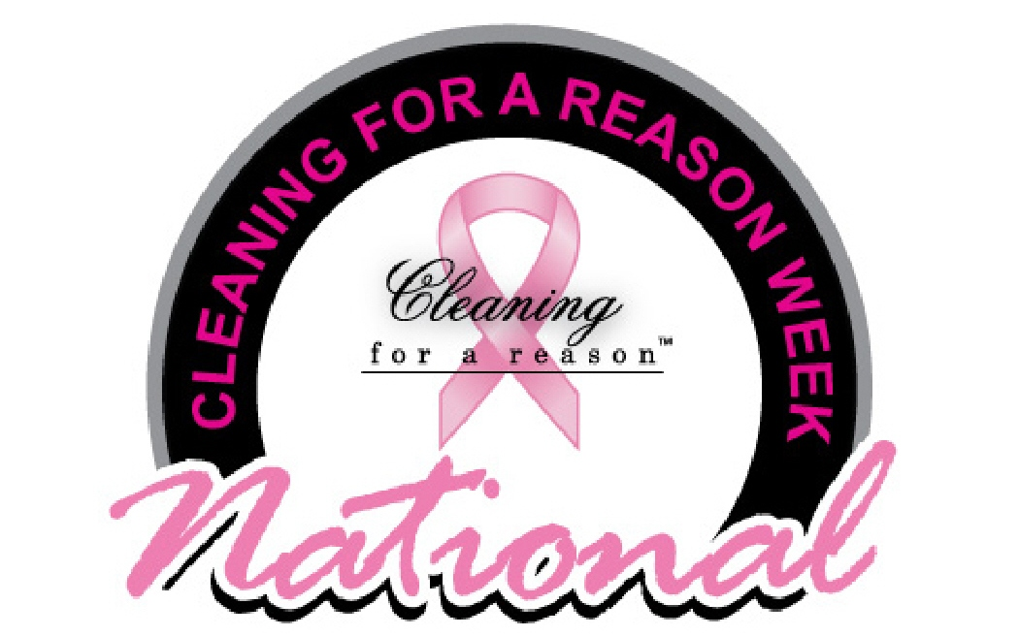
National Cleaning For A Reason Week April 18–24

How To Request a Proclamation From the Mayor or Governor
Start the process now, as the wheels of government turn slowly. Cities and states may vary regarding proclamation procedures. In most cases, these are the basic steps:
- Locate the appropriate city or state government website.
- Find a tab called "Mayor's Page" or "Governor's Page." Also look for "Ceremonial" or "Forms" down the side or across the top. If you do not see any of these, use the site's Search feature with the word "proclamation." Another option is the "Contact Us" link. That area allows you to write a brief message, such as: How do I ask the Mayor to issue a proclamation declaring National Cleaning For A Reason Week April 18–24?
- Note that a staff person will likely reply and email a form for you to complete. Respond as directed. If you receive no response or no form is available, you can email or mail the attached proclamation template to the mayor or governor’s office. Include a cover letter on your official company letterhead.* Most will be happy to use this proclamation as it stands.
- Follow up with a phone call — just to be sure your request for a proclamation has arrived.
- When you have confirmation that the proclamation has been signed, contact local media to suggest a news item, interview, or photo with the mayor or governor.
- Email a copy of the signed proclamation and any media coverage or photos to info@cleaningforareason.org.
_________________________
*If using the attached proclamation template, include a cover letter stating the following:

- You are a cleaning affiliate of the Cleaning For A Reason nonprofit.
- You are requesting a proclamation declaring National Cleaning For A Reason Week April 18–24.
- National Cleaning For A Reason Week April 18–24 was established to raise awareness that this nonprofit provides free house cleaning to any household battling cancer, serving any woman, man, or child with a cancer diagnosis.
- By raising awareness of the nonprofit, more cancer patients in need of services can be assisted.
- Information will reach cancer patients and potential cleaning affiliates as well as offer an opportunity for individuals and companies to give back to their communities with donations of any size.

National Cleaning For A Reason Week April 18–24
PROCLAMATION
<City or State>
EXECUTIVE OFFICE of <MAYOR OR GOVERNOR>

WHEREAS, Cleaning For A Reason is a non-profit that provides free professional house cleaning to cancer patients. Cleaning For A Reason matches any household with a woman, man, or child battling cancer with cleaning companies who are willing to donate their time and services; and
WHEREAS, cancer is very real and affects so many, so a simple house cleaning can be of assistance to cancer patients and allow these patients to focus on their health, while the nonprofit focuses on patients’ homes during this time of need. For the patients and their families, this service is invaluable; and
WHEREAS, Cleaning For A Reason has more than 1,200 volunteer cleaning companies and continues to grow every year as more companies participate. Together they improve the lives of those stricken with cancer. There are millions of cancer patients, who do not have the resources to hire an outside service to clean during this difficult time; and
WHEREAS, Cleaning For A Reason must continue to help cancer patients and give back to the communities by making a difference in the lives of these individuals. A donation of any size is always greatly appreciated by Cleaning For A Reason in order to make this mission possible.
NOW, THEREFORE I, _________________(Name), __________________(Title)
_________________________________________________________, (City/State)
DO HEREBY PROCLAIM April 18–24 National Cleaning For A Reason Week in (City/State)_________________, and I encourage all citizens to recognize the contributions of Cleaning For A Reason and express appreciation for their commitment to free house cleanings for cancer patients in the hope of achieving optimum health and easing the stress of not only cancer patients, but also their families that often become the main caregiver.
IN WITNESS WHEREOF I have hereto set my hand and caused the Great Seal of the
_____________________________________________________________________
to be affixed.
Done at the ____________on this the _____ day of _________, Two thousand and nineteen.
By:
Title:
Attest:
Title:

